Case 4-A81-Eur- **Roman Glass-Two Handles-Thin Encircling Trails-**1st to 4th century CE

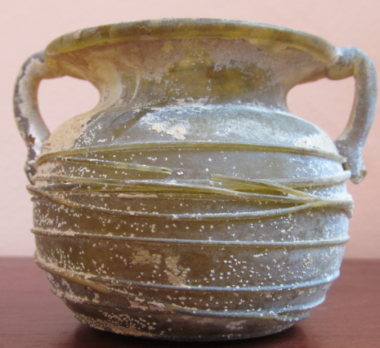 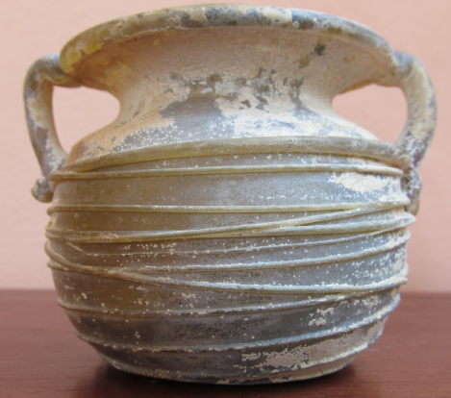

**Case no.: 4**

**Accession Number: A81**

**Formal Label: Roman Glass-Two Handles-Thin Encircling Trails-**1st to 4th century CE

**Display Description:** Jar with two handles. Globular. Pale translucent green with wide rim folded out. Handles applied. Very thin trails irregularly encircling jar about 10 times. Indentation in base. Pontil mark.

**LC Classification:** NK.5107.3

**Date or Time Horizon:** Late 6th to early 7th century CE

**Geographical Area:** Jerusalem, Judea

**GPS coordinates:** 31º46'5.95" N 35º12'49.36" E

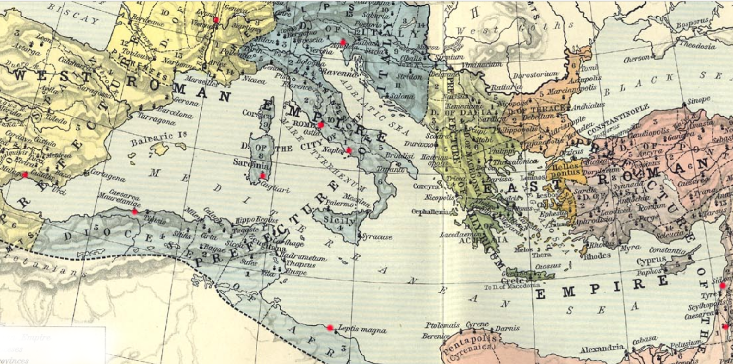

**Map,** Roman Empire, 533-600. Red markers indicate diffusion of Sidonian glassblowing. From http://users.clas.ufl.edu/ufhatch/pages/03-Sci-Rev/SCI-REV-Home/Historical-Research/maps/shepherd-c-052.jpg

**Cultural Affiliation:**

**Medium:** Blown glass

**Dimensions:**

Height: Height: 6.5 cm

Inner Diameter (rim): 4 cm

Outer Diameter (rim): 6.5 cm

Maximum Diameter: 8.5 cm

**Weight:** 101 g

**Condition: original**

**Provenance:** Ex-Touma Dabbah Collection

**Discussion:**

On the eastern borders of the Roman Empire, according to Pliny ca 79 CE (*Historia Naturalis* 36), glassblowing (*flatu figurare*, "shaping by breath") was developed by the Sidonians of the Phoenician Pentapolis.

Glassblowing diffused because of factors political, legal and economic (see Fleming 1999). Politically, Augustus ended a century of civil strife in Italy and created a network of pacified provinces. Legally, Augustus ushered in an era of speedy and safe travel under *Pax Romana* that protected citizens of Rome from Syria to Spain. Economically, Italy experienced a boom that attracted and invigorated entrepreneurialism among artisans and merchants.

Consequently, manySidonian glassblowers immigrated to Italy, established a *vicus vetrarius* or “glassworkers’ quarter” in the vicinity of the Roman Porta Capena in the heart of the Empire (M. Bacchelli et al. 1995) and thereby introduced glassblowing to Romans (Stern 1995, 68-69). Other Italian ateliers were established in Ticino (Biaggio 1991), Naples (Campania; Stern 1976) and Aquileia (Calvi 1991; Scatozza Höricht; Calvi 1968).

Glass-blowing trade expanded to Switzerland (Avenches), to Gaul (*Lugdunum*, i.e., Lyon and Saintes; Nenna 1997; Hochuli-Gysel 1992; B. Velde and A. Hochuli-Gysel 1996), Corsica (Cagliari; Canivet, 1969: fig 15) to the south of the Iberian Peninsula (Price 1987), Libya (Tripoli; Aurigemma 1958, pl.15, fig. 19), and Roman-Berber North Africa (*Caesarea Mauretaniae*, i.e., Tipaza; Lance 1967).

**References:**

Aurigemma, Salvatore. 1958. *Un Sepolcreto Punico-Pomano sotto il ‘Forte della Vite’ o ‘Forte nord-Ouest’ in Tripoli (Libia)*. Tripoli: Department of antiquities, Administration of Tripolitania.

Bacchelli, M. et al. 1995. “Nuove scoperte sulla prove- nienza dei panelli in opus sectile vitreo della collezione Gorga.” In *Atti del 2 Convegno dell' Associazione Italiana per lo Studio e la Conservazione del Mosaico, Rome, 5-7 December 1994*. Bordighera, pp. 447-66.

Biaggio Simona, S. 1991. I vetri romani provenienti dalle terre dell' attuale Cantone Ticino (Locarno 1991*); HelvArch* 22 (1991) 78-143.

Calvi, M. 1968. *I vetri romani del Museo di Aquileia*. Aquileia: Museo di Aquileia.

Calvi, M. 1991. “Arte vetraria Ticinese e arte vetraria Aquileiese: raffronti e analogie," *Helvetia Archeolgia* 22: 133-43.

Canivet, M.T.F. 1969. “I Vetri de Cornus conservati al Museo di Cagliari,” *Journal of Glass Studies* 11).

Fadić, Ivo. 1997. *Trasparenze imperiali Vetri romani dalla Croazia [Dalmatia],* exhibition catalogue. Rome: Palazzo Barberini; Milano: Skira.

Fleming, Stuart J. 1999. *Roman glass: reflections on cultural change*. Philadelphia: University of Pennsylvania Museum.

Giacchero, M. 1974. *Edictum Diocletiani et Collegarum de pretiis rerum venalium*. Genova : Istituto di storia antica e scienze ausiliarie.

Goitein S.D. 1967. *A Mediterranean Society 1: Economic Foundations.* Berkeley: University of California Press.

Hochuli-Gysel, A. 1992. “Römisches Glas aus dem Südwesten von Frankreich,” *Annales du 12e Congrès de l'Association internationale pour l'histoire du verre, Vienne (Wien) 26 - 31 août 1991 12, 1991* (Amsterdam), pp. 79-88.

Isings, C. 1957. *Roman Glass from Dated Finds*. Archaeologica Traiectina 9, Groningen.

Lance, Sergel. 1967.*Verrerie antique de tipasa: ouvrage publié avec le concours du conseil de la récherche scientifique en algerie, avec l' autorization du bureau des antiquites de l' algerie*. Paris:  Édition-Diffusion de Boccard.

Masseroli, Sara. 1998. *Vetro e vetri: preziose iridescenze*.  Milano: Electa.

Morel, J. *et al*. 1992. “Un atelier de verrier du milieu du 1er siècle apr. J.-C. à Avenches,” *Archäologie der Schweiz: Mitteilungsblatt der Schweizerischen Gesellschaft für Ur- und Frühgeschichte* 15: 2-17.

Nenna, M.-D. *et al*. 1997. “L'atelier de verrier de Lyon, du 1er siècle après J.-C., et l'origine des verres ‘romains’,” *Révue d'Archeometrie* 21: 81-87.

Newby, M. and K. Painter, eds. 1991. *Roman Glass: Two Centuries of Art and Invention*. The Society of Antiquaries of London, Occasional Paper 13. London: The Society of Antiquaries of London.

Price, J. 1987. “Glass Vessel Production in Southern Iberia in the First and Second Centuries A.D.: A Survey of the Archeological Evidence,” *Journal of the Glass Studies* 29: 30-39.

Scatozza Höricht, L.A. 1991. "Syrian Elements among the Glass from Pompeii and Herculaneum [Campania]," in Newby, M. and K. Painter, eds. 1991. *Roman Glass: Two Centuries of Art and Invention*. The Society of Antiquaries of London, Occasional Paper 13. London: The Society of Antiquaries of London, pp. 76-85.

Stern, E.M. 1976. "A Small Glass Bottle on Three Pinched Feet [from Campania]," in *Festoen Opgedragen aan A.N. Zadoks-Josephus fitta bij haar zeventigste verjaardag (Scripta Archaeologica Groningana* 6, Groningen), pp. 527-38

Stern, E. M. and Birgit Schlick-Nolte. 1994. *Early Glass of the Ancient World 1600 B.C. - A.D. 50: Ernesto Wolf Collection.* Ostfildern: Verlag Gerd Hatje; New York: Distributed in the U.S.A. by Distributed Art Publishers.

Stern, E. M. 1995. [*The Toledo Museum of Art: Roman mold-blown glass: the first through sixth centuries*](http://www.worldcat.org/title/toledo-museum-of-art-roman-mold-blown-glass-the-first-through-sixth-centuries/oclc/264987943&referer=brief_results). Rome: "L'Erma" di Bretschneider in association with the Toledo Museum of Art.

Stern, E. M. 2001. [*Roman, Byzantine, and early medieval glass, 10 BCE-700 CE: Ernesto Wolf collection*](http://www.worldcat.org/title/roman-byzantine-and-early-medieval-glass-10-bce-700-ce-ernesto-wolf-collection/oclc/48267849&referer=brief_results). Ostfildern: Hatje Cantz; New York: Distributed in the U.S.A. by Distributed Art Publishers.

|  |  |
| --- | --- |
|  |  |

Tatton-Brown, V. 1991. "The Roman Empire". In H. Tait (ed.) *Five Thousand Years of Glass*. London: British Museum Press, pp. 62–97.

van Lith, [Sophia Maria Elisabeth](https://www.amazon.com/s/ref=dp_byline_sr_book_1?ie=UTF8&text=Sophia+Maria+Elisabeth+van+Lith&search-alias=books&field-author=Sophia+Maria+Elisabeth+van+Lith&sort=relevancerank) and K. Randsborg. 1985. "Roman Glass in the West: A Social Study," *Berichten van de Rijksdienst voor het Oudheidkundig Bodemonderzoek* 35 (1985) 413-32 and also as a separate reprint by Rijksdienst voor het Outheidkundig Bodemonderzoek.

Velde, B. and A. Hochuli-Gysel. 1996. "Correlations between Antimony, Manganese and Iron Content in Gallo-Roman Glass," *Annales du 13e Congrès de l'Association Internationale pour l'Histoire du Verre, Pays-Bas*, 13, 1995, pp. 185-91.

Weinberg, Gladys Davidson and the Corning Museum of Glass, eds. 1988. *Excavations at Jalame: site of a glass factory in Late Roman Palestine*. Columbia: University of Missouri Press.

*of a glass factory in Late Roman Palestine*. Columbia: University of Missouri Press.